INTRODUCTION
Patient stratification is the process of dividing a patient population into meaningful subgroups based on shared characteristics, enabling more targeted treatment plans and mental health interventions. This project applies K-Means Clustering, an unsupervised machine learning algorithm to stratify patients in a mental health survey dataset into distinct risk groups.
The goal is to identify clusters of individuals who share similar patterns of indoor confinement duration and mood swing severity, which are two important indicators of mental health deterioration. By segmenting the population, healthcare providers can prioritise resources for high-risk patients more efficiently.
DATASET DESCRIPTION
The Mental Health Dataset contains survey responses from 292,364 individuals. The following two features are selected for clustering:
- Days Indoors – how many days an individual has stayed indoors (e.g., 1–14 days, 15–30 days, more than 2 months).
- Mood Swings – self-reported severity of mood swings: Low, Medium, or High.
These features were encoded as ordinal numeric values so that K-Means could compute distances between data points.

CODE IMPLEMENTATION

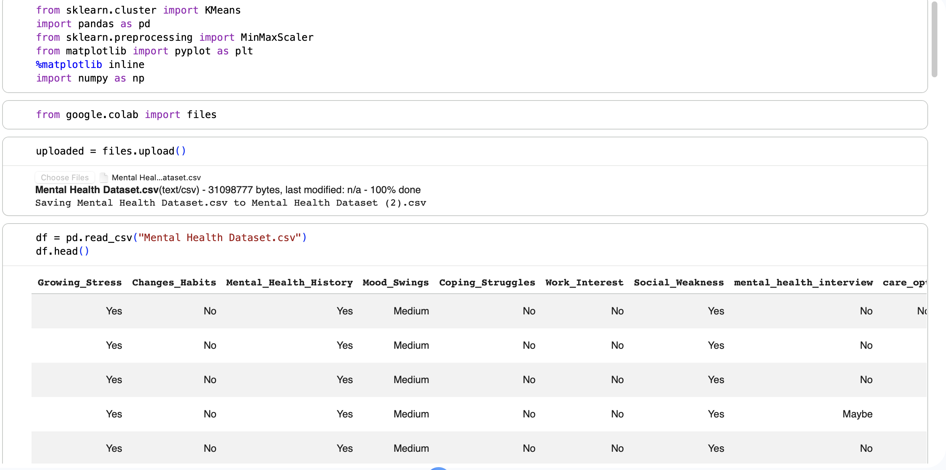

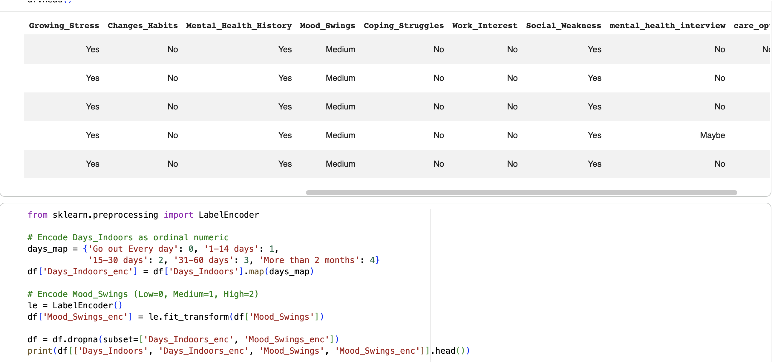

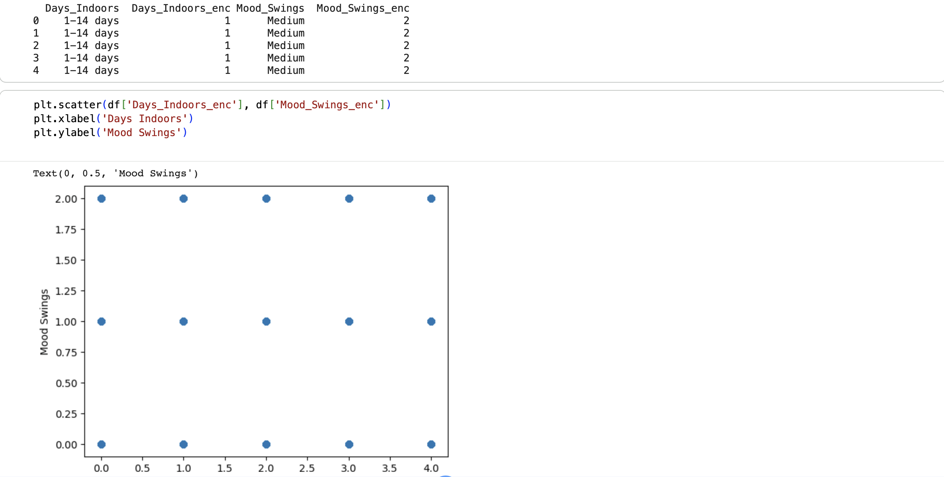

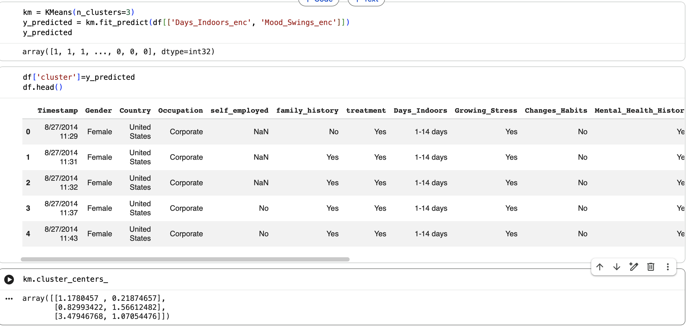

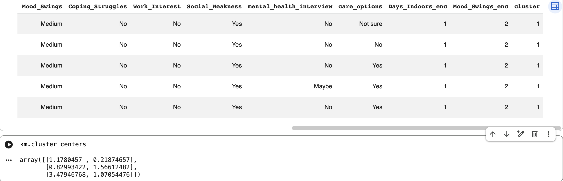

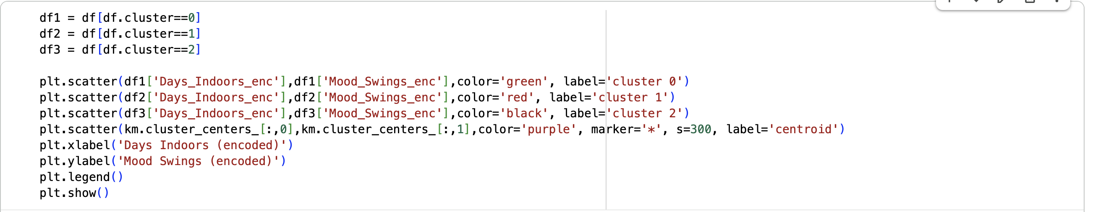

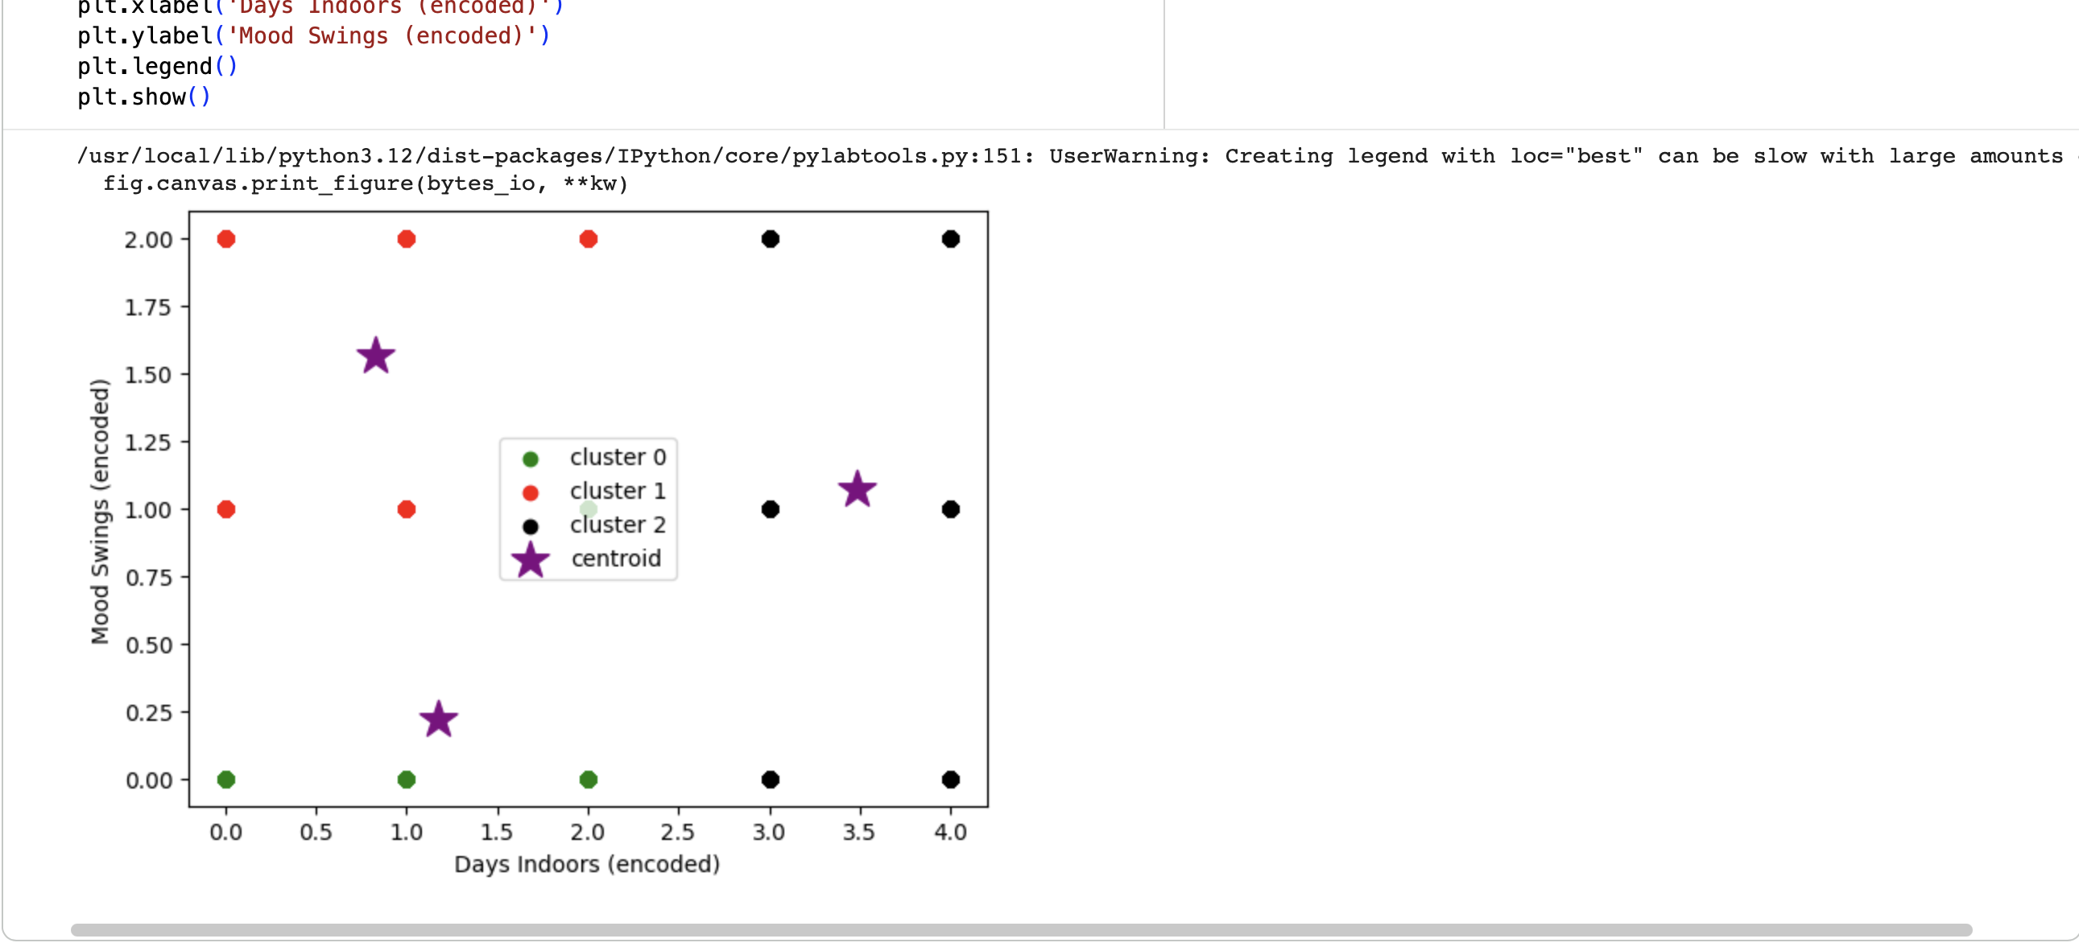

RESULT/INTERPRETATION

After running K-Means with k = 3, 500 patients from the dataset were assigned to three clusters. The table below summarises each cluster's centroid position and its clinical interpretation:
- Cluster 0 (Green) - Low risk: This group consists of patients with relatively low days indoor and moderately low mood swings. These are generally coping well and have maintained outdoor activity.

- Cluster1 (Red) - High risk: This group of patients shows most alarming profile because centroid at maximum isolation corresponding to more than 2 months indoors and maximum mood swings. They are primary target for immediate medical intervention.

- Cluster2 (Black) - Moderate risk: This group has the largest cluster, these patients report high mood swings but relatively short indoor durations. This can possibly be marking underlying conditions requiring targeted therapy.

CONCLUSION

This project successfully demonstrated the application of K-Means Clustering for patient stratification using the Mental Health Survey Dataset. By selecting two clinically relevant features i.e. Days Indoors and Mood Swings and encoding them numerically, the algorithm identified three distinct patient groups corresponding to low, moderate, and high mental health risk levels.
The resulting clusters provide actionable insights: healthcare providers can now direct intensive resources to the high-risk isolated group (Cluster 1), design targeted emotional support programmes for the distressed-but-active group (Cluster 2) and offer preventive monitoring for the low-risk group (Cluster 0). This unsupervised approach is particularly valuable in mental health settings where labelled diagnosis data may be limited or unavailable.

